**Step by Step CONCATENATE Process for Wdesk**

1. First you will need to build the tables below, in the first summary sheet of the business process. Below is what the tables should look like. The position of the tables are the key to streamline this process please make sure that the tables are in the correct position. My guidelines for this is to make sure that “In-scope Components” title is in cell E25, that the “Asset Accounts addressed” is located in E29, and that the “In-Scope Locations” title is in cell Q29.
   1. To build the tables from scratch is as simple as copying and pasting the correct sections of the Control Universe. The first section to grab would be the “In-Scope Companies/Components. (See Below). You will need to do this until your tables match this image.

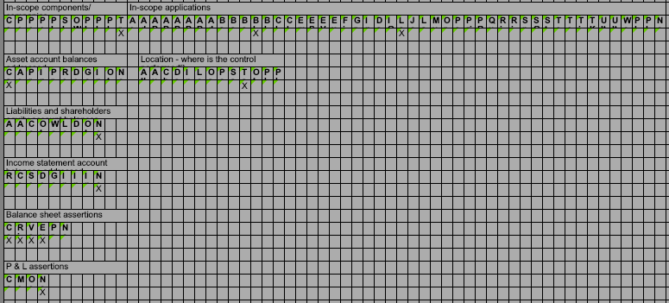

Make sure that these titles are in Cells E25 for in-scope companies, E29 for Asset accounts, and Q29 for Locations.

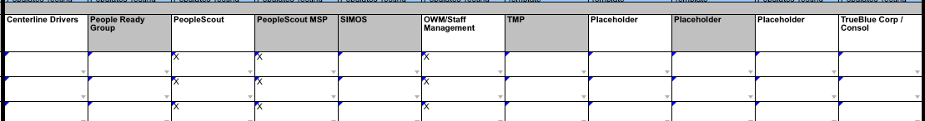

Make sure just to grab this row, and that you link to it.

1. After you build this table you will need to populate the cells in the tables that have “X” in them. The best way to this is to copy and paste the applicable section of the control universe. When copying and pasting these items you need to make sure that the pasting setting is set “Create links from …” to “All Cells” and set the setting as default.

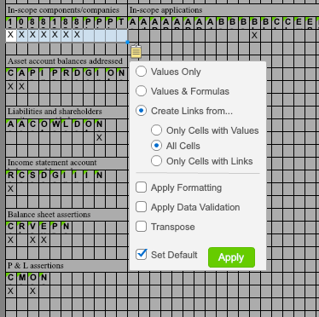

1. After you have populated all the cells for each section you can Hide Columns E through BK and begin to populate the appropriate cells in Column C. This should be the quickest step of the process. Below are premade formulas for you to copy and paste into the appropriate cell. Some helpful tips for this step is to make sure that the cell format is “Accounting.” Another item is to just copy and paste to the cell and make sure to change the format to match the other cells.

* In-Scope Components
  + =CONCATENATEIF($E$27:O27,"X", ", ", $E$26:$O$26)
* In-Scope Locations
  + =CONCATENATEIF($Q$31:$AC$31,"X", ", ", $Q$30:$AC$30)
* In-Scope Applications
  + =CONCATENATEIF($P$27:$BK$27,"X", ", ", $P$26:$BK$26)
* Asset Account Balances Addresses
  + =CONCATENATEIF($E$31:$O$31,"X",",",$E$30:$O$30)
* Liabilities and Shareholders' Equity Account Balances Addressed
  + =CONCATENATEIF($E$35:$M$35,"X",",",$E$34:$M$34)
* Income Statement Account Balances Addressed
  + =CONCATENATEIF($E$39:$M$39,"X",",",$E$38:$M$38)
* Balance Sheet Assertion(s) Addressed
  + =CONCATENATEIF($E$43:$J$43,"X",",",$E$42:$J$42)
* P & L Assertion(s) Addressed
  + =CONCATENATEIF($E$47:$H$47,"X",",",$E$46:$H$46)

1. After you have populated all the applicable cells in Column C, you can “Share” and move on to the next summary sheet in the business process.
2. Now that you have a table already built you can populate the subsequent summary sheets more efficiently. First you will want to clean the columns to the right of Column D. This can be done quickly, by simply highlighting all the Columns and right click and select “Remove Links”, then right clicking again to clear the contents.
3. Now the Columns should be cleaned you can simply copy and paste the tables from the summary sheet that has the tables from Step 1.
   1. Some helpful tips for this step:
      1. Make sure you first copy and paste the “In-scope Companies” and “In-scope Applications” tables first. Then you can copy and paste the Account sections. Wdesk doesn’t like it when you copy and paste the all the tables.
      2. 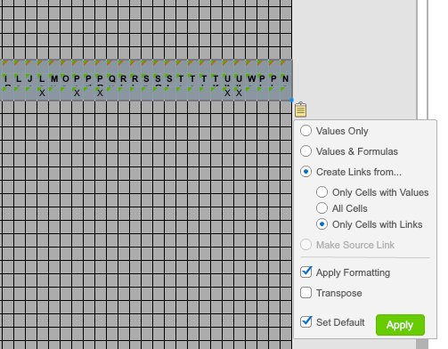Next you will need to change the pasting setting to reflect the image to the right. This is ensuring that you paste exact copies of the first summary sheet tables.
4. 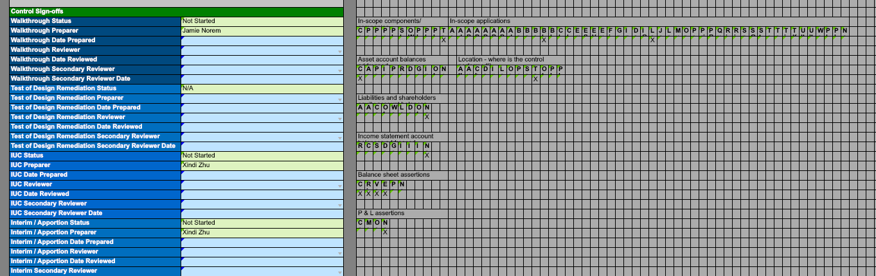Your summary sheet should look like the image below. Next you will have to remove the links from all the Cells that are below the lettering for each section. This will make the populating of the sections for this control faster.
5. Now you will need to remove the links for the cells that have an “X” in them or are blank and below the bolded wording. (See below)

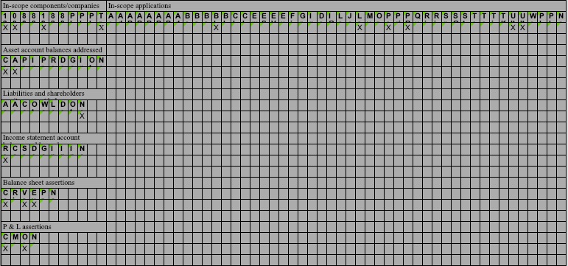

Remove the links from these cells, before you populate them with the information for the appropriate control and section from the Control Universe.

1. After you have removed the links from the appropriate cells you can repeat Steps 2 through 4.
2. Repeat these steps for each summary sheet.

**Some Helpful Tips and Tricks.**

* Most common Hotkeys used during this process:
  + CTRL + C 🡺 Copy selected cells
  + CTRL + V 🡺 Paste
  + CTRL + Arrow Key 🡺 jumps to the next non-blank cell
  + CTRL + SHIFT + Arrow Key 🡺 selects a range of cells stops at the next non-blank cells.
  + CTRL + M 🡺 Merge selected cells
  + CTRL + SHIFT + M 🡺 Unmerge selected cells
* Make the Column width 13 for all columns to the right of Column D. This makes viewing the tables easier.
* Set the ZOOM of the working papers to 100%, for more efficient editing.